Student Navigator
Comprehensive Career Navigation & Academic Platform for Students
A Unified Engineering Curriculum Intelligence, Prerequisite Dependency Mapping, Algorithmic Assessment, Standardized Placement Readiness, and Career Navigation System

Metadata Field | System Specification / Details
Project Name | Student Navigator
Full System Title | Career Navigation & Academic Platform for Students
Architecture Pattern | Decoupled 3-Tier Architecture (React 19 SPA + Express 5 REST API + MongoDB)
Natural Language Engine | Groq Cloud LPU — Llama 3.3 70B Versatile (OpenAI SDK Compliant)
Target Audience | Engineering Students, Academic Mentors, Placement Coordinators, Recruiters
Production Version | Version 1.0.0 (Calibrated & Verified Against Active Codebase)
Verification Status | Feature-Complete based on current implementation; automated testing & hardening recommended.
Author / Team | Core Software Engineering & Architecture Team

[DOCUMENT OBJECTIVE & EXECUTIVE ORIENTATION]
This document is a comprehensive, self-contained project report and technical reference. A reader with zero prior knowledge of this project will be able to read this document and fully understand what the application is, why it was created, how students interact with it, how the frontend and backend communicate, how database records are structured, how intelligent algorithms calculate placement readiness and career recommendations, and how the complete codebase is deployed.

Document Table of Contents
Document Part | Part Title / Focus Area | Included Sections & Technical Scope
PART I | UNDERSTANDING THE PROJECT | Sections 1 - 9: Project at a Glance, Problem Statement, Solution, Objectives, Target Users, Benefits, Feature Overview
PART II | HOW A USER USES THE PROJECT | Sections 10 - 29: End-to-End User Journey, Module-by-Module Deep Dives (What User Sees/Does/Gets), UI Figures & Captions
PART III | WHAT HAPPENS INSIDE THE SYSTEM | Sections 30 - 44: System Architecture, Layer Interactions, ERD, Security, Scoring Formulas, Natural Language Architecture, Data Flows
PART IV | TECHNICAL REFERENCE | Sections 45 - 56: Complete API Registry, Database Models, Folder Structure, Environment Setup, Installation & Seeding Guide
PART V | PROJECT STATUS & MASTER MATRICES | Sections 57 - 63: Master Feature Matrix, Production Readiness Audit, Roadmap, Technical Glossary, One-Page Summary

PART I
UNDERSTANDING THE PROJECT

1. Project at a Glance
Project Name: Student Navigator
Full Project Title: Career Navigation & Academic Platform for Students
One-Line Description: An integrated academic syllabus intelligence, prerequisite dependency visualizer, algorithmic practice hub, standardized placement readiness evaluator, and career recommendation ecosystem for undergraduate engineering students.
Dimension | Project at a Glance Summary
What is this project? | A full-stack, dark-themed single-page web platform that consolidates academic curricula (40+ subjects, 200+ topics) with practical coding problems, dynamic quizzes, placement mock tests, verified scholarships, and an intelligent interactive study assistant.
Who is it designed for? | Undergraduate engineering students (B.Tech / B.E. / BCA / MCA across CS, IT, Electronics, Electrical, and Mechanical branches), faculty mentors, and campus placement coordinators.
What problem does it solve? | Eliminates fragmented study resources, reveals hidden prerequisite dependencies via visual graphs, benchmarks placement readiness with a 100-point formula, and matches students to verified scholarships and tech career paths.
What can students do? | Study structured topic notes & video lectures, ask questions to an interactive study assistant, solve LeetCode/HackerRank coding challenges, take dynamic quizzes, sit for timed mock tests, track daily streaks, and apply for matched scholarships.
How does data flow? | User Action -> React 19 Frontend -> Axios HTTP Client (Bearer JWT) -> Express 5 API Gateway -> Mongoose 8 ODM -> MongoDB -> Groq Cloud Engine -> Real-time UI updates with Recharts and ReactFlow.
Why is it unique? | It is not just a study portal or job board; it continuously calculates a standardized 100-point Career Readiness Score and provides a 6-factor algorithmic Career Recommendation based on verified student activity.

2. Problem Statement & Problem-to-Solution Mapping
Higher education in engineering faces a persistent structural gap between university syllabus coverage and industry placement standards. The table below maps every real-world student challenge directly to the implemented solution in Student Navigator:
Identified Problem | Real-World Challenge | Platform Solution | Technical Implementation
Scattered Learning Resources | Students spend hours searching across fragmented websites for notes, video lectures, and question banks. | Centralized Subject & Topic Catalog | 40+ engineering subjects with curated notes, textbook citations, and categorized YouTube video links.
Unclear Prerequisite Flows | Students struggle with advanced topics because they haven't mastered prerequisite foundational concepts. | Interactive Prerequisite DAG Graphs | ReactFlow directed acyclic graph visualizer color-coding completed, unlocked, and locked prerequisite nodes.
Uncertain Placement Readiness | Students have no objective benchmark to evaluate if they are prepared for technical campus recruitment drives. | 100-Point Career Readiness Score | Standardized formula: 30% Topics + 20% Quizzes + 20% Coding + 10% Assignments + 20% Placement Tests.
Opaque Career Pathways | Students are unsure which skills, DSA topics, and capstone projects are required for specific job roles. | 6-Factor Career Recommendation Engine | Algorithmic matching across skills, subject mastery, quiz scores, coding practice, and career roadmap phases.
Missed Financial Aid Deadlines | Eligible students miss valuable scholarships due to fragmented portals and unmonitored deadline dates. | Verified Scholarship Hub & Tracker | 7-criteria eligibility matching, automated status badges (Open, Closing Soon, Closed), and deadline reminders.
Unassisted Self-Study Hurdles | Students get stuck when self-studying complex technical concepts late at night without mentor access. | Context-Aware Interactive Study Assistant | Embedded Groq Llama 3.3 70B assistant providing structured explanations, exam tips, and one-click note saving.

3. Objectives & Expected Outcomes
- Primary Objective 1: Deliver a production-ready MERN portal supporting 40+ engineering subjects and 200+ topics with persistent progress tracking.
- Primary Objective 2: Implement a multi-variable 100-point Placement Readiness Score reflecting curriculum coverage, quizzes, coding, assignments, and mock tests.
- Primary Objective 3: Build a 6-factor algorithmic Career Recommendation Engine that identifies skill gaps and generates milestone roadmaps.
- Primary Objective 4: Deploy interactive ReactFlow directed acyclic graphs (DAGs) enforcing visual prerequisite dependencies.
- Primary Objective 5: Integrate Groq Cloud LLM inference (Llama 3.3 70B) for context-bound academic tutoring and persistent student notes.
- Primary Objective 6: Provide an indexed Scholarship Finder featuring 7-criteria matching and real-time deadline lifecycle countdowns.

PART II
HOW A USER USES THE PROJECT

This section details the platform from the perspective of an active student, providing deep dives into each major module with exact descriptions of what the user sees, what actions they can take, what happens internally, and what results are delivered.

4. End-to-End User Journey Workflow
+---------------------------------------------------------------------------------------------------+
| COMPLETE END-TO-END USER JOURNEY |
+---------------------------------------------------------------------------------------------------+
[1. Onboarding] Student registers with Degree, Branch, Year, CGPA, Skills, & Career Goals
│ -> Password hashed with Bcrypt (10 rounds) -> Welcome Email via Nodemailer
▼
[2. Cockpit Dashboard] Views 100-pt Placement Readiness Score, Readiness Tier, & Dynamic Next Best Action
│ -> Reviews Scholarship Alerts (< 7 days left) and Placement Checklist
▼
[3. Curriculum Discovery] Explores 40+ Engineering Subjects (DSA, OS, DBMS, Networks, Calculus, AI/ML)
│ -> Inspects interactive ReactFlow Prerequisite DAG Graph for dependency flow
▼
[4. Topic Study Hub] Reads structured notes, watches curated YouTube lectures, reviews textbooks
│ -> Consults Interactive Study Assistant (Llama 3.3 70B) for instant analogies & exam tips
▼
[5. Hands-on Practice] Solves topic-aligned LeetCode/HackerRank coding problems -> Toggles solve status
│ -> Launches Dynamic 10-Question Balanced Quiz -> Shuffled options & score logged
▼
[6. Placement Simulation] Sits for timed Placement Mock Tests -> Receives topic-by-topic analytics breakdown
│ -> Submits practical assignments -> Auto-unlocks Gamified Achievement Badges
▼
[7. Career & Financial] Reviews 6-Factor Career Recommendations (Skill Gaps, Salary, Capstone Projects)
-> Applies for verified scholarships with active deadline lifecycle countdowns

5. Authentication & Student Onboarding
What the user sees: A modern, dark glassmorphic login and registration interface with fields for full name, email, password, degree, branch, year of study, skills, interests, and career ambitions.
What the user can do: The user enters their academic credentials, selects their engineering domain, and clicks 'Create Account' or 'Sign In'.
What happens after the action: The client stores the returned JWT token in localStorage and immediately navigates to the personalized student dashboard.
What the system does internally: The backend trims and lowercases the email, hashes the password with Bcrypt (10 rounds), saves the User document in MongoDB, signs a 30-day JWT token, and triggers an asynchronous welcome email via Nodemailer.
Result delivered to the user: The student receives full access to their personalized academic cockpit and a welcome email containing their profile credentials summary.
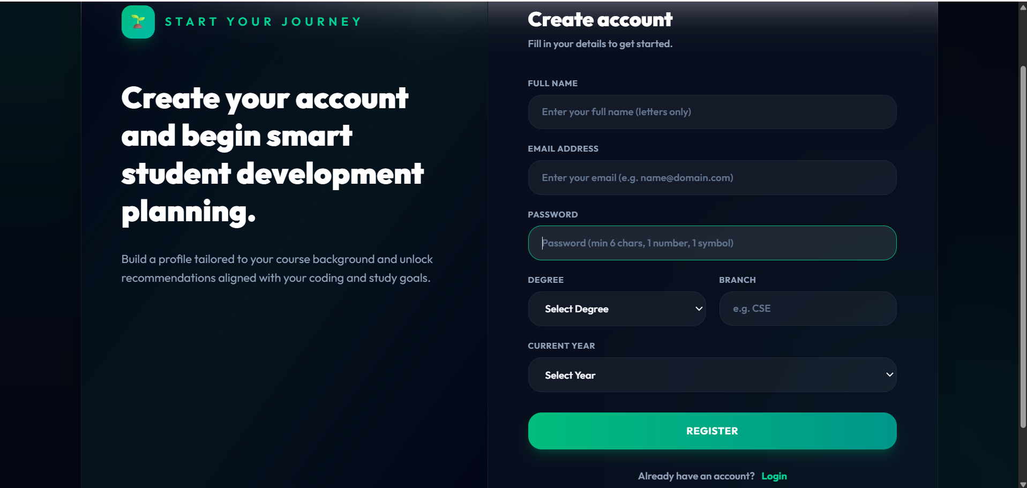
Figure 1 — Student Registration & Login Interface: The registration interface captures complete student academic metadata including branch, year, CGPA, and career goals to power recommendation algorithms.

6. Unified Student Dashboard
What the user sees: A comprehensive cockpit displaying the Standardized Career Readiness Meter (0–100%), Placement Tier badge, Data-Driven Checklist, dynamic 'Next Best Action 🚀' card, Closing-Soon Scholarship alerts, and Recent Activity logs.
What the user can do: The student reviews their readiness breakdown, clicks on recommended actions (e.g. 'Study Core Topics' or 'Solve 5 DSA Problems'), or navigates to bookmarked scholarships.
What happens after the action: Clicking any action seamlessly routes the student to the corresponding subject, test center, or scholarship details page.
What the system does internally: The backend dashboardController executes parallel Promise.all queries across 11 MongoDB collections (Topics, Quizzes, CodingProgress, TestResults, Scholarships) to compute scores in real time.
Result delivered to the user: Instant, transparent visibility into overall placement preparedness and clear guidance on the next highest-impact study task.
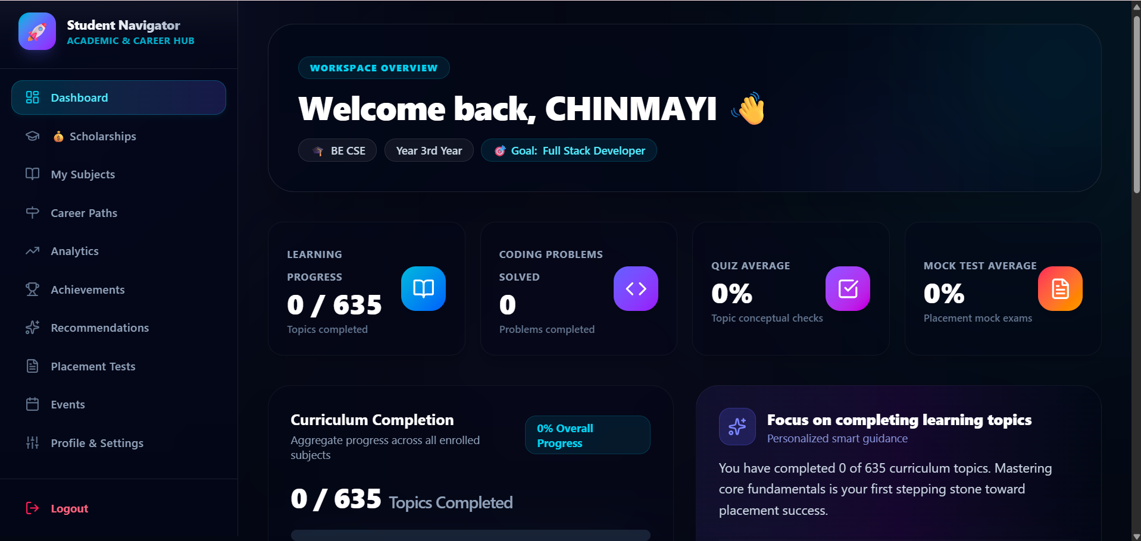
Figure 2 — Unified Student Dashboard Cockpit: The main cockpit displays real-time readiness scores, placement checklist milestones, high-match scholarships, and dynamic next best actions.

7. Subjects & Curriculum Catalog
What the user sees: A searchable grid of 40+ engineering subjects (DSA, OS, DBMS, DAA, AI/ML, Cloud Computing, Networks, Calculus, Physics, etc.) with difficulty tags, topic counts, and individual progress bars.
What the user can do: The student searches subjects by keyword, filters by difficulty, and clicks on any subject card to enter the full syllabus hub.
What happens after the action: The client loads the subject details page, rendering topics, textbook links, curated video lectures, and the interactive prerequisite DAG visualizer.
What the system does internally: The backend subjectController queries MongoDB with sorting and published filters, while progressController computes the percentage of completed topics per subject for the active user.
Result delivered to the user: A clean, structured gateway to the entire university engineering curriculum with live completion metrics.
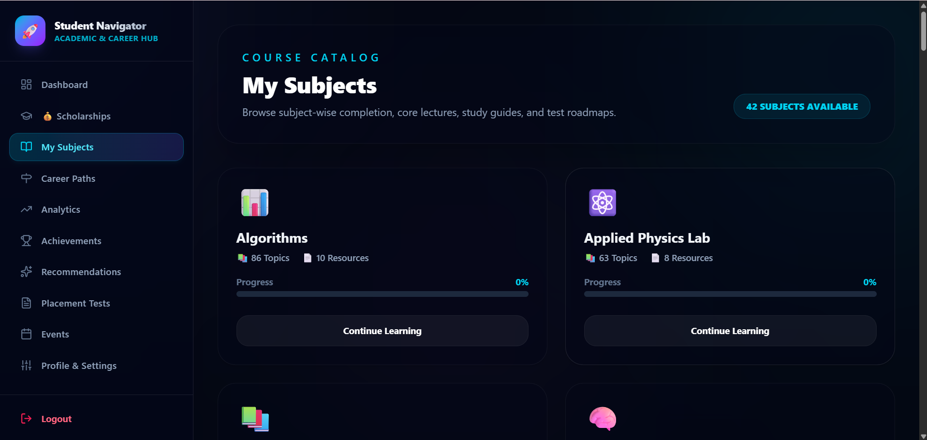
Figure 3 — Engineering Subjects Catalog: Grid of 40+ engineering subjects with search capabilities, difficulty badges, and live student progress indicators.

8. Interactive Prerequisite DAG Dependency Graph
What the user sees: An interactive ReactFlow node-edge graph showing the structured learning flow of topics. Completed topics appear in vibrant Emerald Green with checkmarks, ready-to-study topics appear in Glowing Cyan with lightning icons, and locked topics appear in Dark Slate with lock icons.
What the user can do: The student zooms, pans, drags nodes, inspects prerequisite dependency chains, and clicks unlocked nodes to jump directly to study material.
What happens after the action: The application verifies whether prerequisite topics are completed in UserTopicProgress before permitting topic advancement.
What the system does internally: The prerequisiteController maps topic prerequisite arrays into ReactFlow nodes and directional bezier edges, dynamically setting lock states based on database records.
Result delivered to the user: Clear, gamified visual guidance that prevents students from skipping foundational concepts.
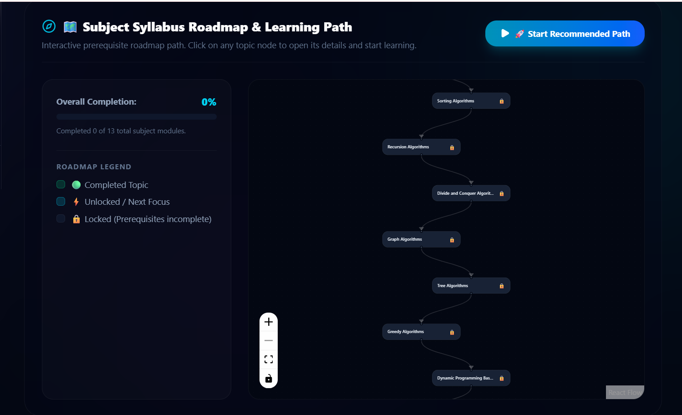
Figure 4 — ReactFlow Prerequisite Dependency Graph: Interactive directed acyclic graph (DAG) showing topic dependencies, color-coded by lock, unlock, and completed status.

9. Topic Learning Hub & Video Lectures
What the user sees: In-depth topic study notes, learning objectives, university question bank references (2M, 6M, 10M), textbook citations, curated YouTube video tutorials, and the floating Smart Study Assistant.
What the user can do: The student studies notes, watches embedded video lectures, toggles topic completion, and prompts the study assistant for clarifications.
What happens after the action: Toggling completion updates UserTopicProgress in MongoDB, recalculating the student's Career Readiness score and checking achievement badge rules.
What the system does internally: The progressController records completedAt timestamps, increments topic counters, and triggers performanceAchievementService checks.
Result delivered to the user: Mastery of individual syllabus units with automated progress tracking and instant milestone updates.
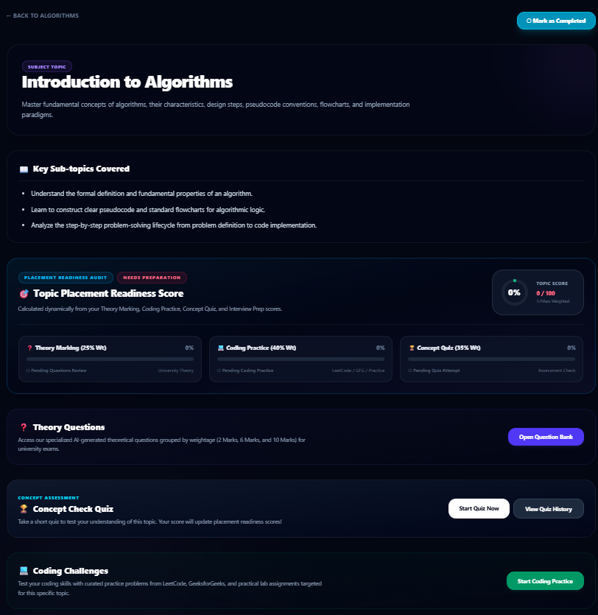
Figure 5 — Topic Comprehensive Study View: Detailed syllabus topic page with structured notes, curated YouTube video links, textbook citations, and mark-based exam question banks.

10. Context-Aware Smart Study Assistant & Notes
What the user sees: A floating, collapsible chat panel embedded directly in topic pages with Quick Action buttons: 'Explain Simply 💡', 'Give Examples 🔍', 'Revision Notes 📝', 'Interview Prep 🎯', 'Real-world Use 🌐', and 'Common Mistakes ⚠️'.
What the user can do: The student clicks a quick action or types a custom question regarding the current topic, reads the structured explanation, and clicks 'Save Note'.
What happens after the action: The assistant response is formatted in clean Markdown with exam tips, reading time estimation, and follow-up query suggestions.
What the system does internally: The assistantController forwards the query with topic context to Groq Cloud API (Llama 3.3 70B), classifies the question (Category A/B/C), parses metadata, and aiNoteController saves notes to MongoDB.
Result delivered to the user: Instant 24/7 personalized academic tutoring and a permanent library of revision notes accessible from the student profile.
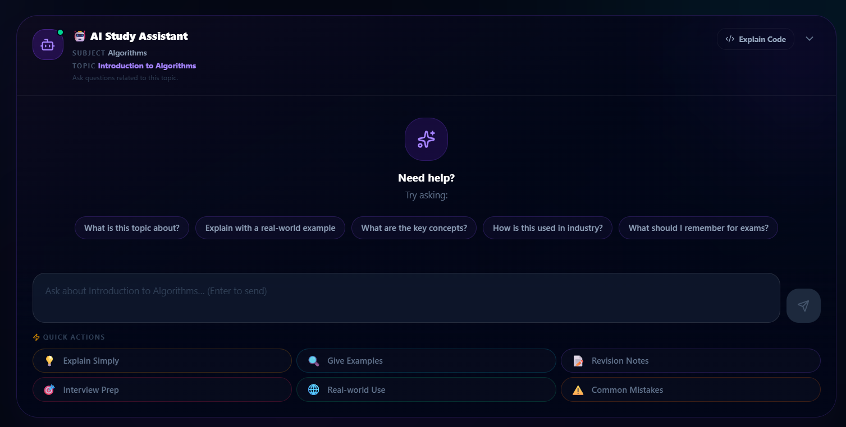
Figure 6 — Context-Bound Smart Study Assistant: Floating chat panel powered by Groq Llama 3.3 70B with one-click quick prompts, exam revision tips, and personal note saving.

11. Algorithmic Coding Practice System
What the user sees: A curated list of coding challenges linked to each topic, displaying platform tags (LeetCode, HackerRank, GeeksforGeeks), difficulty badges (Easy, Medium, Hard), problem statements, and solve toggle checkboxes.
What the user can do: The student opens the external coding link, solves the problem in their preferred IDE/platform, and checks the solve box on Student Navigator.
What happens after the action: The problem is marked solved in UserCodingProgress, incrementing the coding score component of the Placement Readiness gauge.
What the system does internally: The codingProblemController updates database records and automatically awards the 'Coding Champion 💻' achievement when 50 problems are solved.
Result delivered to the user: Structured transition from academic theory to hands-on algorithmic interview problem solving.
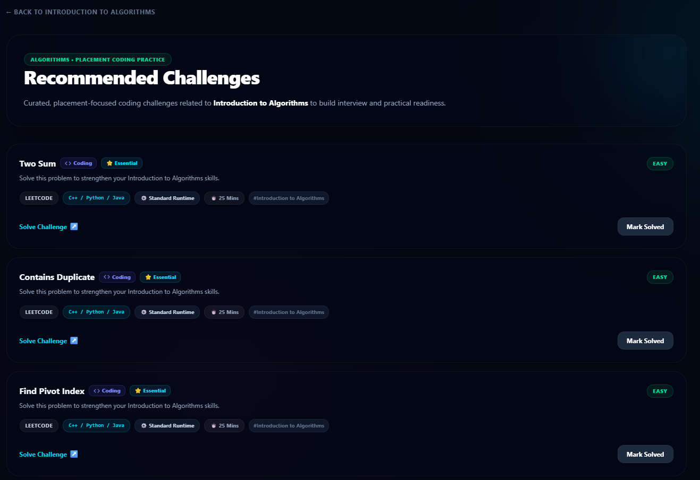
Figure 7 — Topic Algorithmic Coding Hub: Topic-aligned programming challenges with platform badges (LeetCode, GFG), difficulty tags, and solve progress tracking.

12. Dynamic 10-Question Concept Quizzes
What the user sees: A full-featured quiz interface serving exactly 10 questions with progress counters, timer countdowns, and shuffled multiple-choice radio options.
What the user can do: The student answers all 10 questions under timed conditions and clicks 'Submit Quiz'.
What happens after the action: The client navigates to the Quiz Result score report showing percentage, passing status, and question-by-question explanations.
What the system does internally: The quizController balances questions across 4 categories (4 Theory, 2 Logic, 2 Application, 2 Code), snapshots served questions to persist across page refreshes, grades answers, and checks for the 'Quiz Master 📝' badge.
Result delivered to the user: Objective, instantaneous feedback on concept retention with detailed explanatory answer keys.
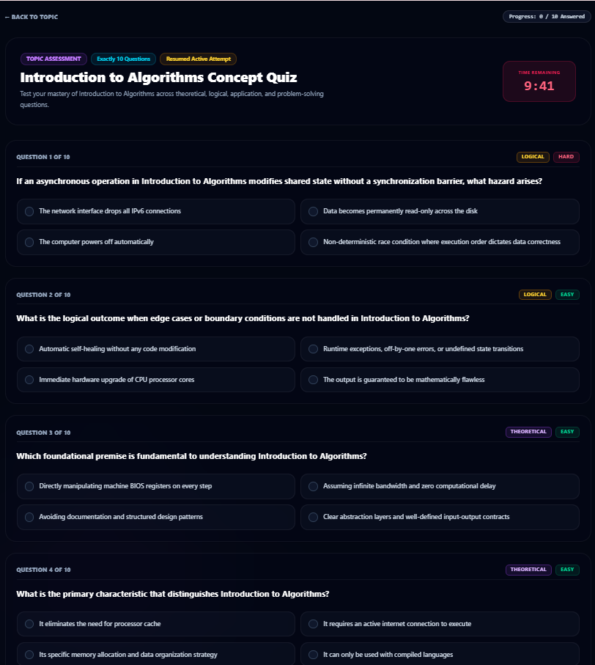📸 [UI SCREENSHOT: DYNAMIC TOPIC QUIZ INTERFACE]
Interactive Dark-Mode View: Dynamic Topic Quiz Interface
Figure 8 — Dynamic Topic Quiz Interface: Timed 10-question assessment interface with balanced question categories, option shuffling, and resilient attempt persistence.

13. Placement Mock Test Center & Analytics
What the user sees: A dedicated test center categorized by Programming & DSA, Core CS, Development, and Placement Mocks, complete with duration, question counts, and historical attempt scores.
What the user can do: The student selects a mock exam, sits for the timed test with negative marking support, and reviews detailed topic performance graphs upon completion.
What happens after the action: The TestResult document stores overall score, time taken, correct/incorrect/unanswered counts, and a granular topic performance map.
What the system does internally: The testController calculates scores, updates test averages for Career Readiness, and unlocks the 'Mock Test Ace 🎯' achievement if score is >= 80%.
Result delivered to the user: Rigorous placement exam simulation with granular diagnostic feedback on technical strengths and weaknesses.
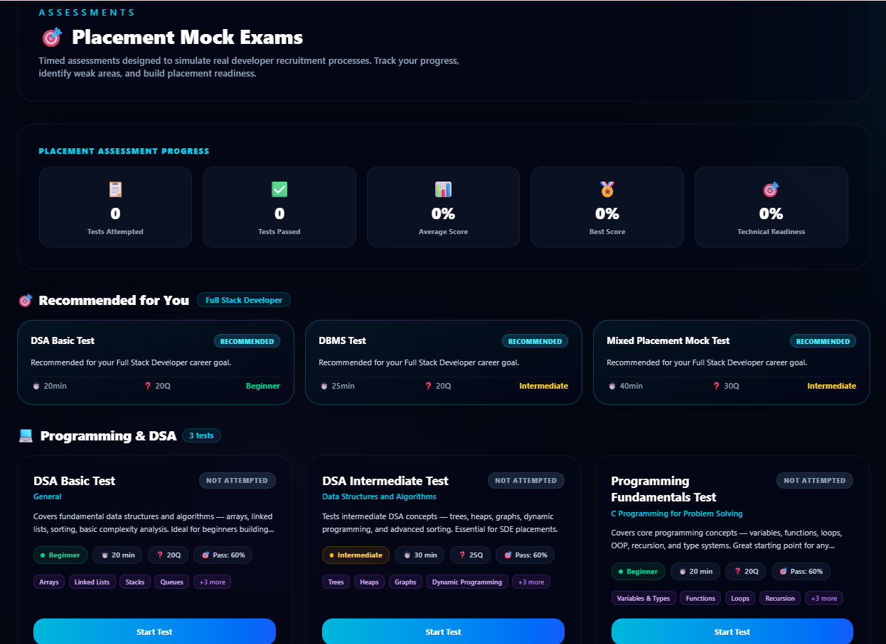
Figure 9 — Placement Mock Examination Center: Comprehensive placement test suite categorized by DSA, Core CS, and Full Mock Exams with detailed topic-level analytics.

14. 6-Factor Algorithmic Career Recommendations & Roadmaps
What the user sees: A ranked list of high-demand tech careers (Cloud Architect, Full-Stack Engineer, AI/ML Specialist, Cybersecurity Analyst, Data Engineer) displaying match percentages, salary ranges, industry demand, skill gap checklists, and why-this-career rationale.
What the user can do: The student explores career blueprints, inspects roadmap phases (Beginner, Intermediate, Advanced), reviews capstone project ideas, and tracks project completion.
What happens after the action: Toggling project statuses updates User.careerProjectProgress, feeding into the career placement readiness score.
What the system does internally: The recommendationService runs 6-factor algorithmic scoring (30% Skills, 25% Subjects, 15% Academics, 10% Coding, 10% Roadmap Progress, 10% Interests) to rank career fit.
Result delivered to the user: Data-driven career guidance showing exactly what skills and capstone projects are needed to become interview-ready.
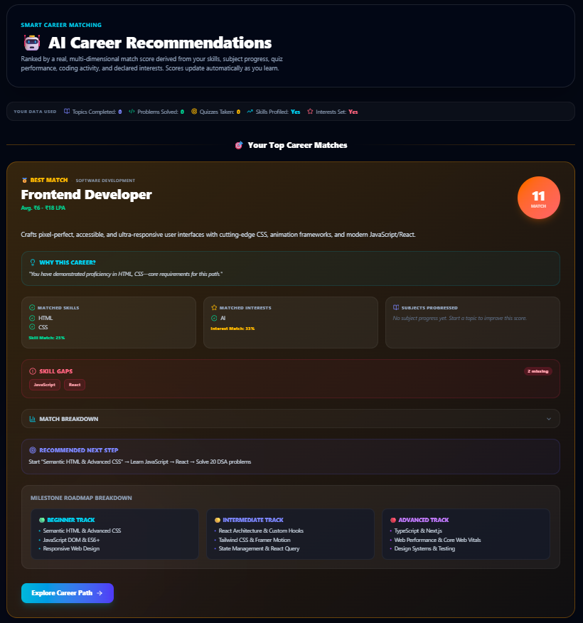
Figure 10 — 6-Factor Algorithmic Career Recommendations: Personalized career recommendations ranked by multi-factor fit score, complete with skill gap checklists and roadmap phases.

15. Verified Scholarship Finder & Application Tracker
What the user sees: A searchable portal of verified corporate and government scholarships with award amounts (e.g. ₹75,000/year), provider badges, match fit scores, deadline countdown badges (Open, Closing Soon, Closed), and official application links.
What the user can do: The student filters by category (Merit, Need, Women, STEM), searches by provider, bookmarks opportunities, updates application statuses (Saved, Applied, Selected), and sets reminder alerts.
What happens after the action: Saved scholarships appear on the main dashboard with real-time countdown alerts for deadlines closing within 7 days.
What the system does internally: The scholarshipController evaluates 7 criteria (Degree, Branch, CGPA, Year, State, Income, Career) to compute 0-100% eligibility scores and derives dynamic lifecycle states.
Result delivered to the user: Direct access to verified financial aid opportunities with automated eligibility scoring and deadline protection.
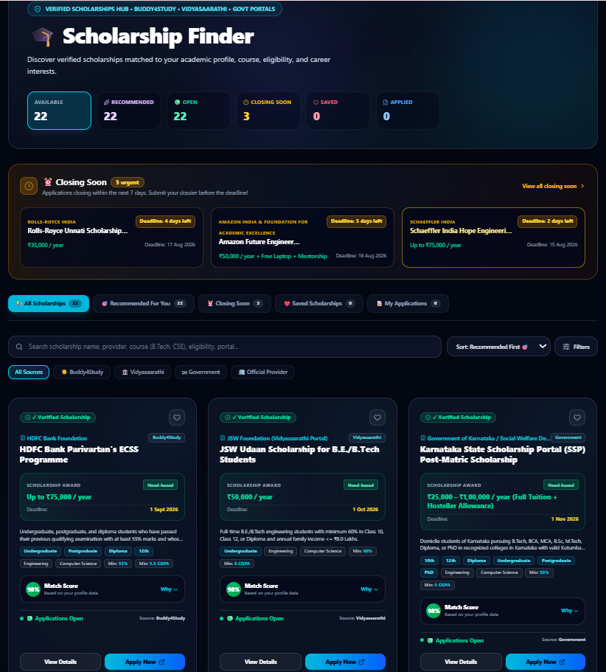
Figure 11 — Verified Scholarship Finder & Tracker: Searchable scholarship discovery portal with 7-criteria eligibility matching, lifecycle countdown badges, and application status tracking.

16. Analytics Dashboard & Learning Streaks
What the user sees: Interactive Recharts data visualizations including weekly learning activity bar charts, monthly progress curves, subject mastery radar graphs, quiz score histories, and daily active learning streaks.
What the user can do: The student analyzes their study consistency, identifies their strongest and weakest academic subjects, and tracks their longest active learning streak.
What happens after the action: The analytics view provides automated study insights highlighting areas needing revision (e.g. 'DBMS completion is below 50%').
What the system does internally: The analyticsController aggregates timestamps across topic completions, quiz submissions, coding progress, and test attempts to compute continuous daily streaks.
Result delivered to the user: Deep visual self-awareness of academic momentum, study consistency, and subject-level proficiency.
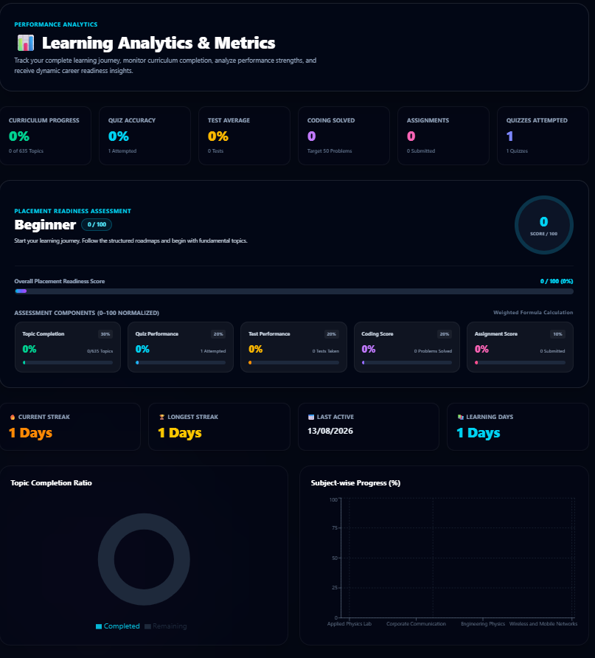
Figure 12 — Recharts Student Analytics Dashboard: Comprehensive learning analytics displaying weekly activity distributions, subject mastery radar charts, and learning streak counters.

PART III
WHAT HAPPENS INSIDE THE SYSTEM

17. Technical Architecture & Layer Interactions
Student Navigator follows a clean, decoupled 3-tier architecture. Below is a comparison between the User Perspective and the Technical Perspective across all operations:
Feature Area | User Perspective (Experience) | Technical Perspective (Internal Execution)
Authentication | User enters email and password on a sleek dark form and logs in. | Express authController verifies bcrypt hash, signs 30-day HMAC-SHA256 JWT token, and returns user payload. Axios interceptor stores token in localStorage and attaches it to subsequent Authorization: Bearer headers.
Prerequisite Graphs | Student sees an interactive graph with green, cyan, and locked topic nodes. | ReactFlow visualizer renders nodes and bezier edges. prerequisiteController computes lock states dynamically by verifying parent topic presence in UserTopicProgress.
Placement Readiness | Student sees a circular meter displaying 78% (Advanced Tier) with a checklist. | dashboardController aggregates 5 MongoDB collections via Promise.all and computes: 30% Topics + 20% Quizzes + 20% Coding + 10% Assignments + 20% Tests.
Interactive Tutoring | Student clicks 'Explain Simply' and reads a clear analogy with exam tips. | Express forwards prompt to Groq Cloud API running llama-3.3-70b-versatile, classifies query (Category A/B/C), strips ---META--- tags, parses follow-up queries, and returns formatted Markdown.
Scholarships | Student sees verified scholarships with a 90% Match badge and 'Closing Soon' tag. | scholarshipController scores 7 profile criteria (Degree, Branch, CGPA, Year, State, Income, Career) and calculates real-time deadline difference: daysRemaining = ceil((deadline - now) / 86400000).
Career Matching | Student sees recommended career cards ranked by percentage with skill gaps. | recommendationService calculates 6 weighted components (30% Skills, 25% Subjects, 15% Academics, 10% Coding, 10% Roadmap, 10% Interests) and synthesizes why-this-career explanations.

18. Database Architecture & Relational Entity-Relationship Diagram
The database layer consists of 23 Mongoose collections with compound unique indexing to ensure data integrity:
+---------------------------------------------------------------------------------------------------+
| DATABASE ENTITY-RELATIONSHIP SCHEMA |
+---------------------------------------------------------------------------------------------------+
[USER] 1 ──── ∞ [USER_TOPIC_PROGRESS] (Compound unique index on user + topic)
│ 1 ──── ∞ [USER_CODING_PROGRESS] (Compound unique index on user + codingProblem)
│ 1 ──── ∞ [USER_QUIZ_RESULT] (Stores full servedQuestions snapshot & answers)
│ 1 ──── ∞ [TEST_RESULT] (Stores mock score, timeTaken, & topicPerformance)
│ 1 ──── ∞ [USER_ASSIGNMENT] (Stores student solution URL & submission status)
│ 1 ──── ∞ [USER_SCHOLARSHIP] (Tracks saved scholarships & application stages)
│ 1 ──── ∞ [USER_ACHIEVEMENT] (Compound unique index on user + badgeName)
│ 1 ──── ∞ [AI_NOTE] (Stores saved study assistant responses per topic)
│ 1 ──── 1 [USER_STREAK] (Maintains daily learning streak counter)
│
[SUBJECT] 1 ──── ∞ [TOPIC] (Contains syllabus notes, videos, & textbooks)
│ 1 ──── ∞ [QUESTION] (Question bank: MCQ, 2-Mark, 6-Mark, 10-Mark)
│ 1 ──── ∞ [TEST] (Placement mock test blueprints)
│ ∞ ──── ∞ [CAREER] (Associated career paths and prerequisite subjects)
│
[TOPIC] 1 ──── ∞ [CODING_PROBLEM] (Platform challenges: LeetCode, HackerRank, GFG)
│ 1 ──── ∞ [QUIZ] (Topic concept assessment pools)
│ 1 ──── ∞ [ASSIGNMENT] (Topic practical lab assignments)
│ ∞ ──── ∞ [TOPIC] (Prerequisites)(Self-referential DAG prerequisite dependencies)

PART IV
TECHNICAL REFERENCE & OPERATIONS MANUAL

19. Complete REST API Endpoint Registry
The backend exposes 22 modular route files mounted under the /api prefix. Every endpoint is documented below with method, route, access level, parameters, and operational description:
Method | Endpoint Route | Access | Operation Purpose | Request Parameters / Body | Controller | Primary Model
POST | /api/auth/register | Public | Register new student account & trigger welcome email | Body: { name, email, password, degree, branch, year, skills, ... } | authController.js | User
POST | /api/auth/login | Public | Authenticate user credentials & issue 30-day JWT token | Body: { email, password } | authController.js | User
GET | /api/user/profile | Protected | Retrieve logged-in student profile, CGPA, & skills | None | userController.js | User
PUT | /api/user/profile | Protected | Update student academic credentials, income, & goals | Body: { degree, branch, year, cgpa, state, familyIncome, ... } | userController.js | User
GET | /api/subjects | Public | List all published engineering subjects | None | subjectController.js | Subject
GET | /api/subjects/:id | Public | Get single subject details, concepts, & resources | Param: :id | subjectController.js | Subject
GET | /api/topics/subject/:subjectId | Public | Get all curriculum topics for a subject | Param: :subjectId | topicController.js | Topic
GET | /api/topics/:id | Public | Get topic syllabus notes, video links, & textbooks | Param: :id | topicController.js | Topic
GET | /api/topics/subject/:subjectId/prerequisites | Public | Get ReactFlow DAG nodes & edges for subject | Param: :subjectId | prerequisiteController.js | Topic / Progress
GET | /api/topics/:topicId/prerequisites | Protected | Get single topic prerequisites & lock status | Param: :topicId | prerequisiteController.js | Topic / Progress
POST | /api/topics | Admin | Create a new curriculum topic | Body: { subject, title, slug, description, order, ... } | topicController.js | Topic
PUT | /api/topics/:id | Admin | Update an existing curriculum topic | Body: { title, description, notes, books, ... } | topicController.js | Topic
DELETE | /api/topics/:id | Admin | Delete a curriculum topic | Param: :id | topicController.js | Topic
GET | /api/progress | Protected | Get topic completion progress for all subjects | None | progressController.js | UserTopicProgress
POST | /api/progress/topic/:topicId | Protected | Toggle topic completed / uncompleted status | Param: :topicId | progressController.js | UserTopicProgress
GET | /api/coding-problems/topic/:topicId | Protected | Get coding problems linked to a topic | Param: :topicId | codingProblemController.js | CodingProblem
POST | /api/coding-problems/progress/:problemId | Protected | Toggle solved status of coding problem | Param: :problemId | codingProblemController.js | UserCodingProgress
GET | /api/quizzes/topic/:topicId | Protected | Get active / dynamic 10-question quiz | Param: :topicId, Query: ?retry=true | quizController.js | Quiz / UserQuizResult
POST | /api/quizzes/submit/:quizId | Protected | Submit quiz answers and compute score | Body: { answers: [{ questionIndex, selectedAnswer }] } | quizController.js | UserQuizResult
GET | /api/quizzes/my-results | Protected | Get student historical quiz attempts log | None | quizController.js | UserQuizResult
GET | /api/quizzes/result/:id | Protected | Get single quiz score report & question review | Param: :id | quizController.js | UserQuizResult
GET | /api/tests | Protected | List all placement mock tests with metadata | None | testController.js | Test
GET | /api/tests/summary | Protected | Get aggregate placement test statistics | None | testController.js | TestResult
GET | /api/tests/:id | Protected | Get single placement test with questions | Param: :id | testController.js | Test
POST | /api/tests/:id/submit | Protected | Submit mock test and calculate score | Body: { answers: { [qId]: answer }, timeTaken } | testController.js | TestResult
GET | /api/tests/result/:id | Protected | Get test result report with topic breakdown | Param: :id | testController.js | TestResult
GET | /api/careers | Protected | Get all career paths with user progress metrics | None | careerController.js | Career
GET | /api/careers/:id | Protected | Get career blueprint, roadmap phases, & projects | Param: :id | careerController.js | Career
POST | /api/careers/:id/project-toggle | Protected | Toggle career capstone project status | Body: { projectId: string } | careerController.js | User
GET | /api/recommendations | Protected | Generate 6-Factor algorithmic career recommendations | None | recommendationController.js | Multiple Models
GET | /api/career-readiness | Protected | Get standardized placement readiness score | None | careerReadinessController.js | Multiple Models
GET | /api/scholarships | Protected | Search & filter scholarships with match score | Query: ?search=&category=&closingSoon= | scholarshipController.js | Scholarship
GET | /api/scholarships/closing-soon | Protected | Get verified scholarships closing <= 7 days | None | scholarshipController.js | Scholarship
POST | /api/scholarships/:id/toggle-save | Protected | Bookmark / unbookmark scholarship | Param: :id | scholarshipController.js | UserScholarship
POST | /api/scholarships/:id/status | Protected | Update tracked application status | Body: { status: 'Submitted' | ... } | scholarshipController.js | UserScholarship
GET | /api/events | Protected | List campus events, hackathons, & webinars | Query: ?type=&mode= | eventController.js | Event
POST | /api/events/:id/toggle-save | Protected | Save / unsave campus event | Param: :id | eventController.js | User
GET | /api/dashboard | Protected | Aggregate parallel dashboard data fetch | None | dashboardController.js | Multiple Models
GET | /api/analytics/dashboard | Protected | Get detailed analytics, weekly stats, & streaks | None | analyticsController.js | Multiple Models
GET | /api/achievements | Protected | Get all 7 milestone badges & auto-unlock | None | achievementController.js | UserAchievement
POST | /api/assistant/chat | Protected | Send context prompt to Groq Llama 3.3 70B | Body: { subject, topic, question, history } | assistantController.js | External LLM
POST | /api/ai-notes | Protected | Save assistant response to student study notes | Body: { subject, topic, question, answer, ... } | aiNoteController.js | AINote
GET | /api/ai-notes | Protected | Get student's saved study notes | None | aiNoteController.js | AINote
DELETE | /api/ai-notes/:id | Protected | Delete a saved study note | Param: :id | aiNoteController.js | AINote
GET | /api/local-file | Public | Secure local PDF/HTML textbook streaming | Query: ?path=file://... | app.js | File System

20. Installation, Configuration, & Seeding Guide
Step-by-step instructions to install, configure, seed, and run Student Navigator from scratch:
# 1. Prerequisites Check
Node.js (v18.0.0 or higher), npm (v9.0.0 or higher), MongoDB (Local Server or Atlas URI)
# 2. Clone Project Repository
git clone <repository-url>
cd Career_platform
# 3. Configure Server Environment Variables (server/.env)
PORT=5000
MONGODB_URI=mongodb://localhost:27017/career_platform
JWT_SECRET=your_super_secret_jwt_signing_key_here
GROQ_API_KEY=gsk_your_groq_cloud_api_key_here
EMAIL_HOST=smtp.gmail.com
EMAIL_PORT=587
EMAIL_USER=your_email@gmail.com
EMAIL_PASS=your_app_specific_email_password
EMAIL_FROM="Student Navigator <noreply@studentnavigator.com>"
# 4. Install Server Dependencies & Seed Master Database
cd server
npm install
npm run seed
# 5. Start Backend REST API (Runs on http://localhost:5000)
npm run dev
# 6. Configure Frontend & Install Dependencies (In a new terminal window)
cd ../client
npm install
# 7. Start Frontend Development Server (Runs on http://localhost:5173)
npm run dev

20.1 Modular Seeding Script Registry
The server includes 40+ granular seeding scripts in server/package.json for specific domains:
NPM Seeding Command | Target Curriculum & Dataset Seeded
npm run seed | Full Master Database Seeding (All subjects, topics, careers, quizzes, & assignments)
npm run seed:dsa | Seeds Data Structures & Algorithms curriculum, notes, and coding challenges
npm run seed:os | Seeds Operating Systems curriculum, kernel concepts, and questions
npm run seed:dbms | Seeds Database Management Systems curriculum, SQL problems, and lab tasks
npm run seed:aiml | Seeds Artificial Intelligence & Machine Learning topics and algorithms
npm run seed:cloud-computing | Seeds Cloud Computing, Virtualization, and Distributed Systems
npm run seed:computer-networks | Seeds Computer Networks, OSI Model, and Protocols
npm run seed:compiler-design | Seeds Compiler Design, Parsing, and Code Generation topics
npm run seed:genai | Seeds Generative Systems, Architecture, and Prompt Engineering topics
npm run seed:calculus | Seeds Single Variable & Multivariable Calculus topics and formula notes

PART V
PROJECT STATUS, AUDIT, & CONCLUSION

21. Master Feature Matrix & Implementation Status
The table below provides a comprehensive audit of all platform capabilities, distinguishing implemented features from planned enhancements:
System Feature | Status | Frontend UI | Controller | Model | Route Mount | Operational Summary
User Authentication | ✅ Implemented | Login.jsx / Register.jsx | authController.js | User | /api/auth/* | Bcrypt hashing, stateless JWT issuance, & welcome emails.
User Profile Management | ✅ Implemented | Profile.jsx | userController.js | User | /api/user/profile | Degree, branch, CGPA, state, income, and skills editing.
Student Dashboard | ✅ Implemented | Dashboard.jsx | dashboardController.js | Multiple Models | /api/dashboard | Real-time readiness gauge, checklist, and scholarship alerts.
Curriculum Subjects Catalog | ✅ Implemented | Subjects.jsx | subjectController.js | Subject | /api/subjects | 40+ engineering subjects with search and progress bars.
Topic Study Hub | ✅ Implemented | TopicDetails.jsx | topicController.js | Topic | /api/topics/:id | Comprehensive notes, YouTube lectures, & question banks.
Prerequisite DAG Graphs | ✅ Implemented | SubjectPrerequisiteGraph.jsx | prerequisiteController.js | Topic / Progress | /api/topics/*/prerequisites | ReactFlow interactive dependency mapping with lock states.
Algorithmic Coding Practice | ✅ Implemented | TopicCoding.jsx | codingProblemController.js | CodingProblem / Progress | /api/coding-problems/* | LeetCode/GFG problem links with solve status tracking.
Dynamic 10-Question Quizzes | ✅ Implemented | QuizPage.jsx | quizController.js | Quiz / UserQuizResult | /api/quizzes/* | Balanced categories, option shuffling, & attempt snapshotting.
Placement Mock Exams | ✅ Implemented | Tests.jsx / TakeTest.jsx | testController.js | Test / TestResult | /api/tests/* | Timed placement tests with topic-level diagnostic feedback.
6-Factor Career Recommender | ✅ Implemented | Recommendations.jsx | recommendationController.js | Multiple Models | /api/recommendations | Multi-factor matching, skill gaps, & roadmap phases.
Verified Scholarship Finder | ✅ Implemented | Scholarships.jsx | scholarshipController.js | Scholarship / UserScholarship | /api/scholarships/* | 7-criteria eligibility matching and deadline countdowns.
Context Study Assistant | ✅ Implemented | AIStudyAssistant.jsx | assistantController.js | External Groq LLM | /api/assistant/chat | Groq Llama 3.3 70B tutoring with note saving.
Gamified Achievement Badges | ✅ Implemented | Achievements.jsx | achievementController.js | UserAchievement | /api/achievements | 7 milestone badges with automated unlock logic.
Recharts Analytics Cockpit | ✅ Implemented | AnalyticsDashboard.jsx | analyticsController.js | Multiple Models | /api/analytics/dashboard | Weekly activity distributions, radar charts, & streaks.
Campus Events & Hackathons | ✅ Implemented | Events.jsx | eventController.js | Event / User | /api/events/* | Campus hackathons, hiring drives, webinars, and reminders.
In-Browser Code Execution | 🔄 Planned | N/A (External Links Used) | N/A | N/A | N/A | Integrated Judge0/Piston compilation container for C++/Java/Python.
Automated Resume Parser | 🔄 Planned | N/A | N/A | N/A | N/A | Automated PDF resume parsing against career blueprints.

22. Production Readiness Assessment & Audit Notes
System Area | Audit Assessment | Technical Evaluation & Production Notes
Authentication & Security | VERIFIED | Bcrypt hashing, stateless JWT issuance, and Axios auth interceptors fully active.
Authorization & RBAC | VERIFIED | Role checks (student and admin) with adminMiddleware guards operational.
Database Schemas & ODM | VERIFIED | 23 Mongoose schemas with compound unique indexing and population references.
Curriculum Data Integrity | VERIFIED | 40+ engineering subjects fully seeded with verified video and textbook citations.
Placement Readiness Engine | VERIFIED | Standardized multi-factor 100-point calculation fully operational.
Career Recommendation Engine | VERIFIED | 6-Factor recommendation scoring with skill gap analysis operational.
Dynamic Assessment Engine | VERIFIED | 10-Question topic quiz balancing, option shuffling, and snapshotting verified.
Natural Language LLM Integration | VERIFIED | Groq Cloud Llama 3.3 70B inference with categorization and note saving active.
Email Notification Subsystem | VERIFIED | Nodemailer SMTP integration for async HTML confirmation active.
Automated Test Coverage | PARTIALLY IMPLEMENTED | Stand-alone verification script exists (quizSystemTest.js); full Jest/Supertest CI suite recommended.
Rate Limiting & Hardening | RECOMMENDED | express-rate-limit recommended on auth and assistant endpoints before large-scale public traffic.

23. One-Page Executive Summary & Project Conclusion
[EXECUTIVE REFRESHER & PROJECT SUMMARY]
STUDENT NAVIGATOR: FINAL ONE-PAGE EXECUTIVE SUMMARY
• PROJECT NAME: Student Navigator
• FULL TITLE: Career Navigation & Academic Platform for Students
• PRIMARY PURPOSE: To provide engineering undergraduates with an all-in-one platform unifying curriculum syllabus mastery, interactive prerequisite DAG graphs, algorithmic coding practice, dynamic assessments, standardized placement readiness benchmarking, and verified scholarship discovery.
• TARGET AUDIENCE: Engineering and Computer Science undergraduates (B.Tech / B.E. / BCA / MCA across CS, IT, Electronics, Electrical, Mechanical), faculty mentors, and campus placement coordinators.
• CORE TECHNOLOGY STACK: MERN Stack (MongoDB, Express.js 5, React 19, Node.js) with Vite 8, Tailwind CSS 4, Recharts 3, ReactFlow 11, and Groq Cloud LPU (Llama 3.3 70B Versatile).
• CORE INTELLIGENT CAPABILITIES:
1. Standardized 100-Point Career Readiness Score (30% Topics + 20% Quizzes + 20% Coding + 10% Assignments + 20% Tests)
2. 6-Factor Algorithmic Career Recommendation Engine (Skills, Subjects, Academics, Coding, Roadmap, Interests)
3. ReactFlow Interactive Prerequisite DAG Graph with dynamic lock/unlock states
4. Dynamic 10-Question Balanced Quizzes with option shuffling & resilient attempt snapshots
5. 7-Criteria Scholarship Eligibility Matching with real-time deadline countdowns
6. Context-Aware Smart Study Assistant with structured explanations, exam tips, and note saving
• IMPLEMENTATION STATUS: Feature-complete based on the current implementation, seeded with 40+ engineering subjects, with automated testing and rate-limiting hardening recommended for large-scale enterprise deployment.

